Pratham U-210905407

Lab8 :DHCP and DNS: Additional Practice Sheet

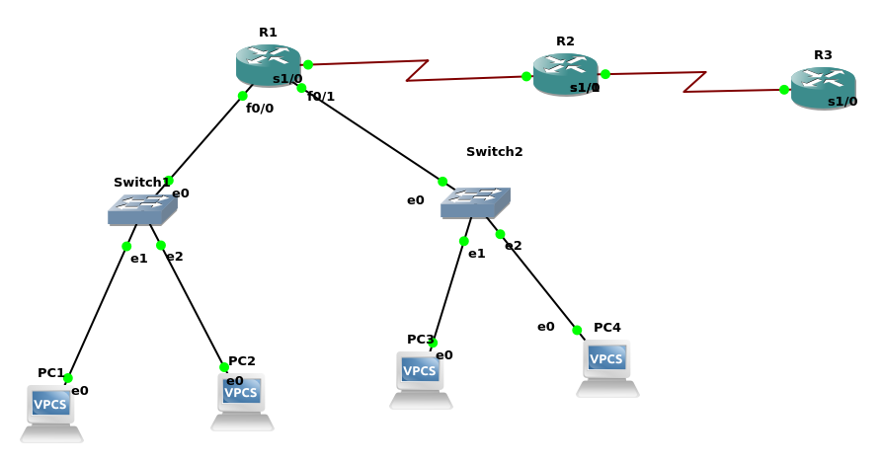

Configure A,B & C
R1
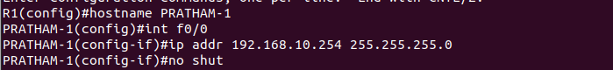
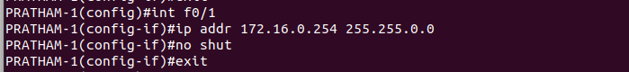
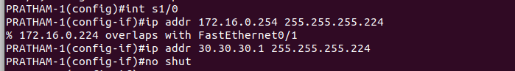
R2
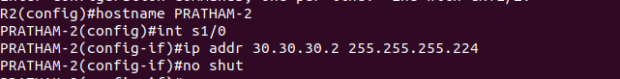
R3

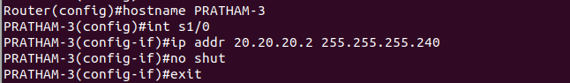

IP routing

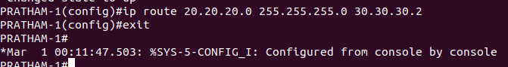

Ping

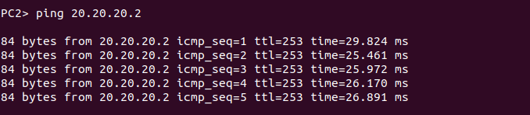

Setting up dns
Testing DNS
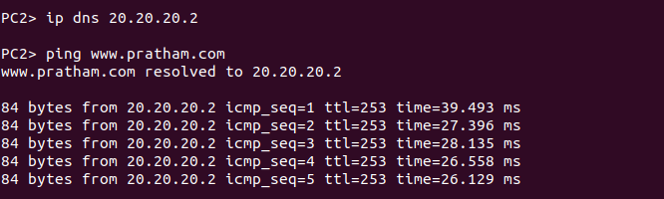

F.

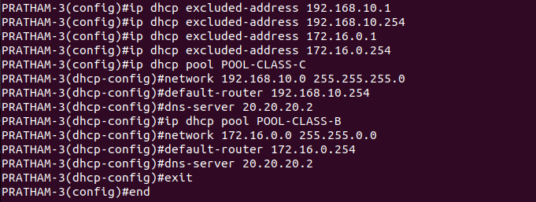

Trying DHCP

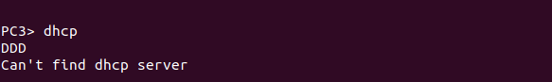

R1

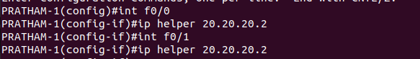

H.
PC1

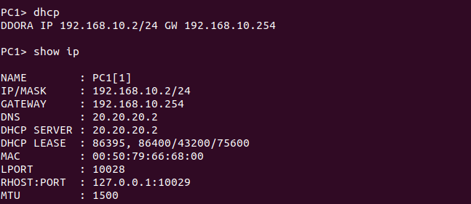
PC 3

